3MDL

Research Proposal

*{our topic}*

|  |  |
| --- | --- |
| **Version:** | 0.1 |
| **Date:** | 29-April-2018 |
| **Authors:** | 3MDL – Data Science Team |

Contents

Contents 1

Introduction 2

Document Purpose 2

Rationale 2

Research Questions 2

Method 2

Data selection 3

Assumptions 3

Techniques 3

Challenges 3

Timeline 4

Appendix A – Data Acquisition 5

Appendix B – Data merging 6

Appendix C – Something Really Cool 7

Document Control

|  |  |  |  |
| --- | --- | --- | --- |
| Version | Purpose | Author | Date |
| 0.1 | Draft Template | 3MDL – DS team | 23-4-2018 |
| 0.2 | Initial Draft |  |  |
|  |  |  |  |
|  |  |  |  |
|  |  |  |  |
| 1.0 | Final version | 3MDL – DS team | 29-4-2018 |

# Introduction

The 3MDL Data Science Team is proposing a research project to determine xxxxx. This project aims to address the XXXXXX in alignment with 3MDL’s strategy vision statement “xxxx”.

## Document Purpose

This proposal document presents an overview of the project rational and articulates the research questions to be investigated. Also presented are findings from the data selection process, proposed modelling techniques and anticipated challenges.

Please refer to Appendices *{cross reference}* for data acquisition and data merger code samples.

# Rationale

*{Introduce and define our broad research area and outline the purpose of our investigation.}.*

The area of interest for this investigation is …..

The proposed research aims to progress the following objectives:

* xxx

# Research Questions

*{introduce our questions. List them. Explain how these relate to the area of research}*

Blah blah … Intro to the list of questions … blah blah

This investigation will attempt to answer the following questions:

1. Xxxx
2. Xxxx
3. Xxxx
4. etc

Blah blah … Explanation of how these relate to the rationale … blah blah blah

# Method

*{identify the question(s) that we will use a predictive regression model to answer, and discuss}*

Blah blah … the regression model question … blah blah

## Data selection

*{Discuss range of datasets we considered. List those we have selected and selection process.   
Discuss how these contribute to answering the question, commonality, how they can be merged – possibly touch on privacy/ethics/legality}*

Blah blah

## Assumptions

*{Summarise our assumptions and basis for forming them}*

## Techniques

*{Discuss techniques used in the data acquisition and merger process and EDA modelling. – highlight our creativity and mastery of R}*

Blah blah

# Challenges

*{Discuss the challenges we anticipate based on the issues we encountered during EDA. Outline our approach for addressing these challenges, propose potential mitigations for any risks.}*

Blah blah

# Timeline

*{Do we want to include one of these? Could use it as a kind of conclusion, also to help link Part A to Part B}*

The proposed timeline for this research project ….

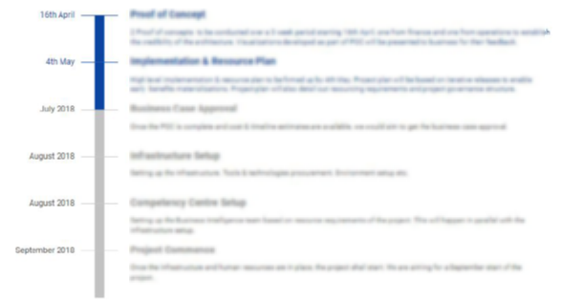

# Appendix A – Data Acquisition

*{code samples – data acquisition}*

# Appendix B – Data merging

*{code samples – data merging_*

# Appendix C – Something Really Cool

*{Not quite sure what but this is the place to put anything we think is great but doesn’t fit within our word count 😉}*